When the Smartphone Turns into a Key: Continental Is Bringing its Key as a Service to Commercial Vehicles
- Technology company adapts digital technology for cars to commercial vehicles
- Keyless vehicle access via smartphone app and Bluetooth enables more efficient fleet management
Zaventem/Belgium, September 2020. Continental is extending its virtual Key as a Service solution from passenger cars to commercial vehicles. The technology company announced this at its virtual press event, Commercial Vehicle Media Days. Key as a Service enables users to open their vehicles and start their engines with a simple command via smartphone or Bluetooth card. “At Continental we see many ways to adapt digital services for passenger cars for use in commercial vehicles,” says Gilles Mabire, Head of the Commercial Vehicles & Services Business Unit, where the company bundles electronic and digital products for commercial vehicles and mobile machinery. “By taking advantage of the technology in our car solutions and tailoring it to the needs of trucks, vans and coaches, we’re bringing products onto the commercial vehicle market that are both innovative and affordable.”
Greater efficiency through hands free vehicle transfer
Physical keys have the disadvantage that they’re not always where the driver needs them. This is often the case with trucks and coaches, which are usually driven by more than one person. The same is true for vehicles that are operated by fleets or car rental services. Continental’s Key-as-a-Service platform makes vehicle handovers much easier. Physical key transfers are unnecessary because vehicles can easily be opened and started with a smartphone app. This offers a number of advantages:
- Driver changes for vehicles en route are more efficient, and there are no waiting times.
- Virtual key handovers are hygienic because physical contacts are minimized.
- Virtual keys can be passed to other users. Mechanics can gain access to the cab and engine without bothering the driver. Maintenance coincides with the driver’s rest period, and the virtual key is transmitted via Key as a Service directly to the mechanic’s smartphone.
- Truck rental companies benefit from secure, smooth handovers that are independent of opening hours.
- Linking the virtual key to the company’s IT systems can streamline vehicle access and usage information.
Today roughly 40 percent of all cars in the world are equipped with key solutions from Continental. In 2019, the technology company supplied more than 34,5 million remote keys. In addition, by late 2020, 100,000 virtual key sets are expected to be licensed. This is a proven technology, and Continental is now applying its wealth of experience from the passenger car segment to commercial vehicles of all sizes and classes.
Simple and secure
As soon as a driver is within 40 meters of the right vehicle, he can use a smartphone app to initiate communication with the commercial vehicle’s electronic key system via Bluetooth Low Energy. There are two layers of security. First, the system relies on secure communication between the remote key system and the vehicle’s ECU. Second, the module in the vehicle uses its integrated SIM card to authenticate the smartphone via Continental Cloud. Opening and starting are possible only if the virtual key from the cloud confirms that the smartphone is authorized for that particular vehicle. As an alternative, a Bluetooth card or NFC (Near Field Communication) card can be used.
Easy retrofitting
Whether installed in a small car or a 40-tonne truck, to implement the virtual key functionality a vehicle is being equipped with either the ACCM (Access & Connected Car Module) or the ACCM+ hardware module. The two modules deliver the same result, but ACCM uses the vehicle’s original key system from the duplicate key, whereas ACCM+ uses the universally protected Remote Cloud Key from Continental. ACCM+ doesn’t require a physical key at all, it just emulates one. The ACCM module can easily be retrofitted. For this purpose, the ECU is connected via cable harness to the vehicle’s OBD interface. The ACCM communicates wirelessly with the standard ECU in the vehicle for keyless access authorization and permission to start the engine. The wireless “key” is operated by the smartphone, thus taking advantage of the vehicle’s functionality.

Continental develops pioneering technologies and services for sustainable and connected mobility of people and their goods. Founded in 1871, the technology company offers safe, efficient, intelligent, and affordable solutions for vehicles, machines, traffic and transportation. In 2019, Continental generated sales of €44.5 billion and currently employs more than 232,000 people in 59 countries and markets.
Continental develops pioneering technologies to make commercial transport safer, more efficient and more connected. The company’s products and services deliver measurable impact for commercial vehicle manufacturers and the aftermarket. They benefit from a broad portfolio and from fully integrated systems. The portfolio includes tires, digital tire monitoring, fleet management, telematic solutions, Electronic Logging Devices (ELD) and tachographs, hoses, air springs, Electronic Control Units (ECU), displays, drivetrain and exhaust aftertreatment systems, sensors, advanced driving assistance systems, as well as eHorizon maps and events and cloud-based services. In 2019, the share of Continental’s global sales for commercial vehicle products, systems and services was €5 billion.
Press contact

Oliver Heil
Manager Media Relations
Commercial Vehicles & Services
Phone: +49 69 7603-9406
E-mail: oliver.heil@continental-corporation.com

Press portal: www.continental-press.com
Media center: www.continental.com/media-center
Event: www.continental.com/commercial-vehicle-days

Pictures and captions
Continental_PP_Key_as_a_Service_Trucks.jpg | Key as a Service enables users to open their vehicles and start engines with a simple command via smartphone.
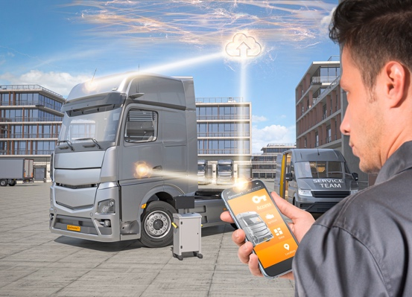Continental_PP_Key_as_a_Service_Trucks_Maintenance.jpg | With Key as a Service, maintenance work can be carried out during the driver's rest period; the virtual key is transmitted directly to the mechanic's smartphone.
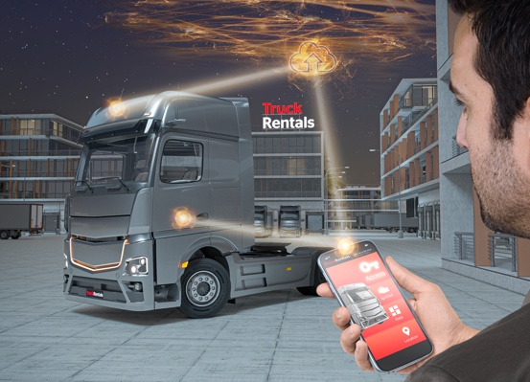Continental_PP_Key_as_a_Service_Trucks_NightRental.jpg | With Key as a Service, truck rental companies benefit from a smooth handover – even outside opening hours.
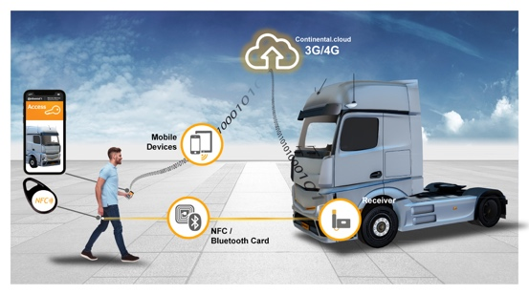Continental_PP_Connections_Key_as_a_Service_Trucks.jpg | Virtual key connection paths

