PRESSE/ PRESS Munich, July 3, 2018

Facts and Figures

- Worldwide 1,500 employees at Day 1
- Sales target in mid-triple-digit-million-euro range
- Both partners have a stake of 50 percent
- 16 locations in 9 countries

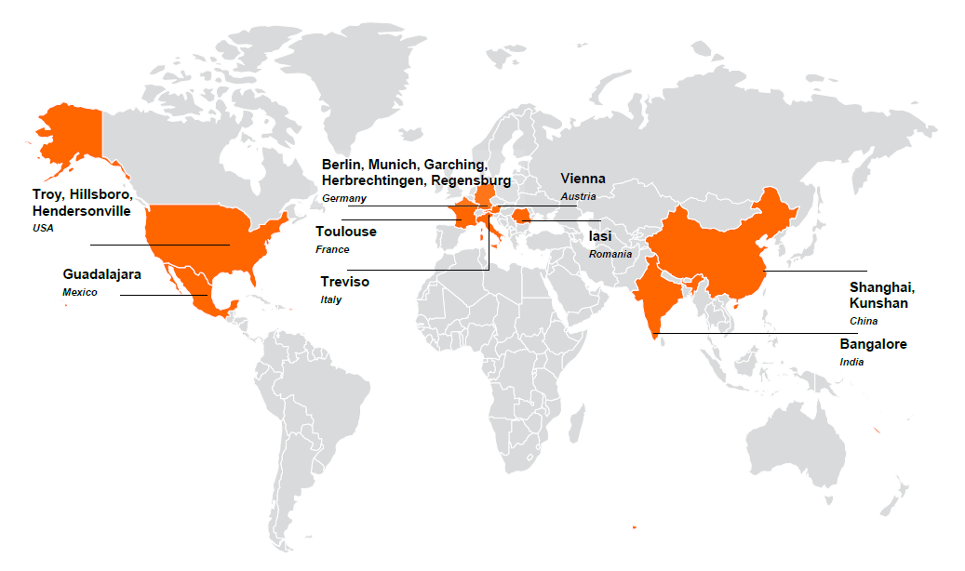

Press contact
Nadine Schian
Phone: +49 89 6213-3769
nadine.schian@osram-continental.com

About OSRAM Continental:
OSRAM Continental GmbH is a joint venture between the technology companies OSRAM and Continental. The globally operating company with headquarters in the Munich region combines modern lighting technologies with electronics and software and offers a broad portfolio of intelligent, innovative lighting solutions for the automotive industry. OSRAM and Continental each hold a 50 percent stake in the joint venture, which has around 1,500 employees at 16 locations worldwide.

More information: www.osram-continental.com

